**The Problem:**

The internet is currently at a weird time in its history, advertisements can be malicious, and invasive. Terrible website design is more common than most people would like to admit, and nothing is being done to fix these problems. With new websites popping up everyday companies are sacrificing overall design and simplicity for quick development and low operating costs. Many of these sites are flooding the internet. In the case of image hosting sites many of them are being bogged down with terrible interfaces and overall website design. We decided we wanted to tackle the problem of over complicated and terribly designed websites rampant with intrusive ads. Our goal was to make image browsing quick easy and reliable.

**Credits:**

**Ryan Nicolosi:** Feedback page, Login page, Account creation page, 3 of the 12 picture pages, contributed to all of the write ups up to this point. Interviewed users and contacted a few of them for usability testing.

**Jesse Bruno:** 3 of 12 picture pages , Assisted with Home Page, Menu Bar as well as contributed to all write ups.

**Nicholas Barrett:** 3 of 12 picture pages, Contact page, conducted interviews and kept up with interviewee’s to make sure site was user friendly.

**Roman Lepishin:** 3 of 12 picture pages, Homepage, drop down menu w/links. HTML/CSS styling. Final edits to all code, cleanup, and quality assurance.

**Audience:**

Our targeted audience was the casual internet user. We were looking for your average person, someone who wants to casually look for interesting pictures on the internet. We built our usability tests around that idea and we asked people with both a lot of internet experience and lighter users of the internet. We wanted to have an advanced view of sites from the experienced users and a novice's view on how we were doing on from the “less-experienced” users. Outside of general internet users, we also were building a website for photographers to upload their images but sadly we were not able to implement a upload portion to our website.

**Solutions:**

Our solution to our site to make it different from others around the internet is the clutter factor that most sites offer. When you login to a site for the first time you are even prompted to register for the site before you can even access the features they offer. We offer free service to our site but there is a register feature that is available. We wanted to create a website that was easy to use and any feature that the user could want would only be a couple clicks away, and it would not be confusing for any users to be able to operate the site, and download an image. You can find any image you desire through the categories and then easily decide on what image you wanted. The website does this faster and is more simpler to navigate through than other competitors. In order to get the image you want on other websites it would take more time than it does on the Wallpaper Inn. Overall, we believe we executed what we set out to do, make a simple functioning website that could have great impact on anyone who would want an image, whether it be for a background or to share to their peers.

**Usability Study: (take some things from the powerpoint as well)**

**Plan:**

While running our test we will ask the users to perform the following tasks:

* Navigate through certain categories and download certain images or images with that resolution.
* Submit a form through our feedback page.
* Navigate through our tabs to certain pages.

This is the personal data of our test subjects:

* **Subject 1:** 21 Year Old Undergraduate Male/Criminal Justice Major/About 30 hrs of Internet use per week.
* **Subject 2:** 19 Year Old Undergraduate Female / Business Marketing Major, Pre-Law Minor / Spends many hours a day on social media
* **Subject 3:** 20 year old undergraduate Male/Meteorology and Astronomy Major/Runs his own photography website and spending at the very least 15 hours a week on the internet.
* **Subject 4:** 20 year old undergraduate Male/Physics Major/Uses the internet heavily on a daily basis up 30 hours a week, most of the time more.

**Test Results:**

**Screens Seen by Subject 1:**

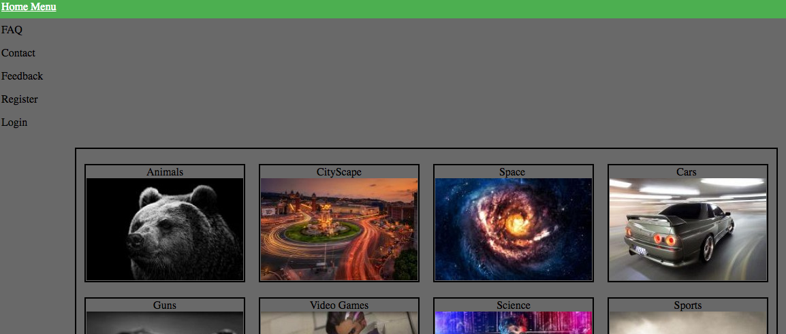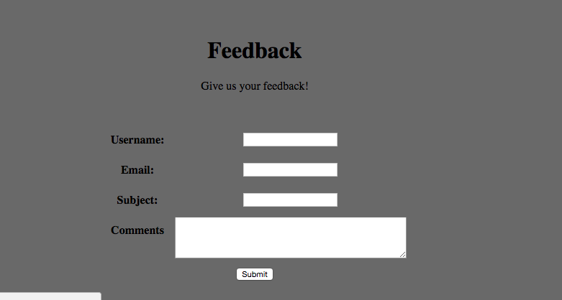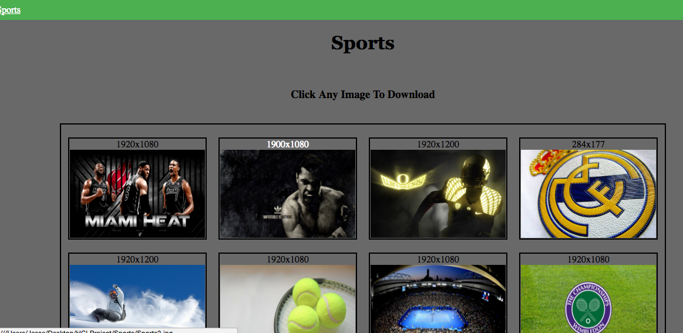

* **Subject 1:** Test subject was able to navigate through the categories with no issue. When instructing them to choose certain categories, they were able to get to that category page in the matter of seconds based on labeling and they loved the white text hover feature that allowed them to see which tab they were clicking on. Test subject was able to enter in all fields of the feedback page with clarity but had very few feedback to give, either based on lack of time with the site or nothing to say at all. Subject was also able to figure out how to download the images after reading the heading above the pictures that states to just click on the image to begin download. Overall, the test subject was able to navigate through the site with ease and perform the certain actions needed.

**Test Results:**

**Screens Seen by Subject 2:**

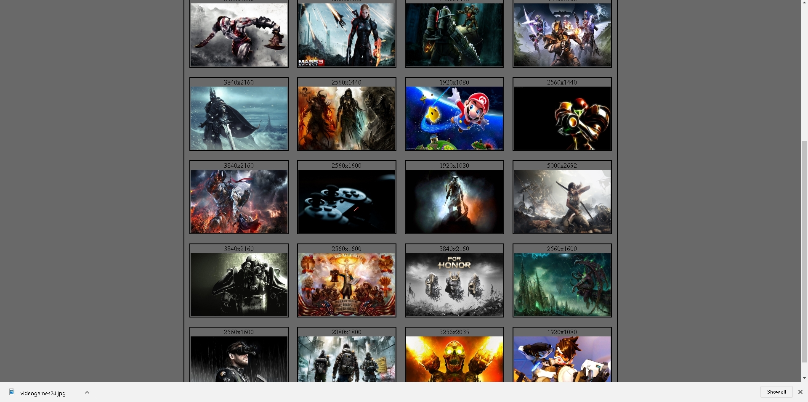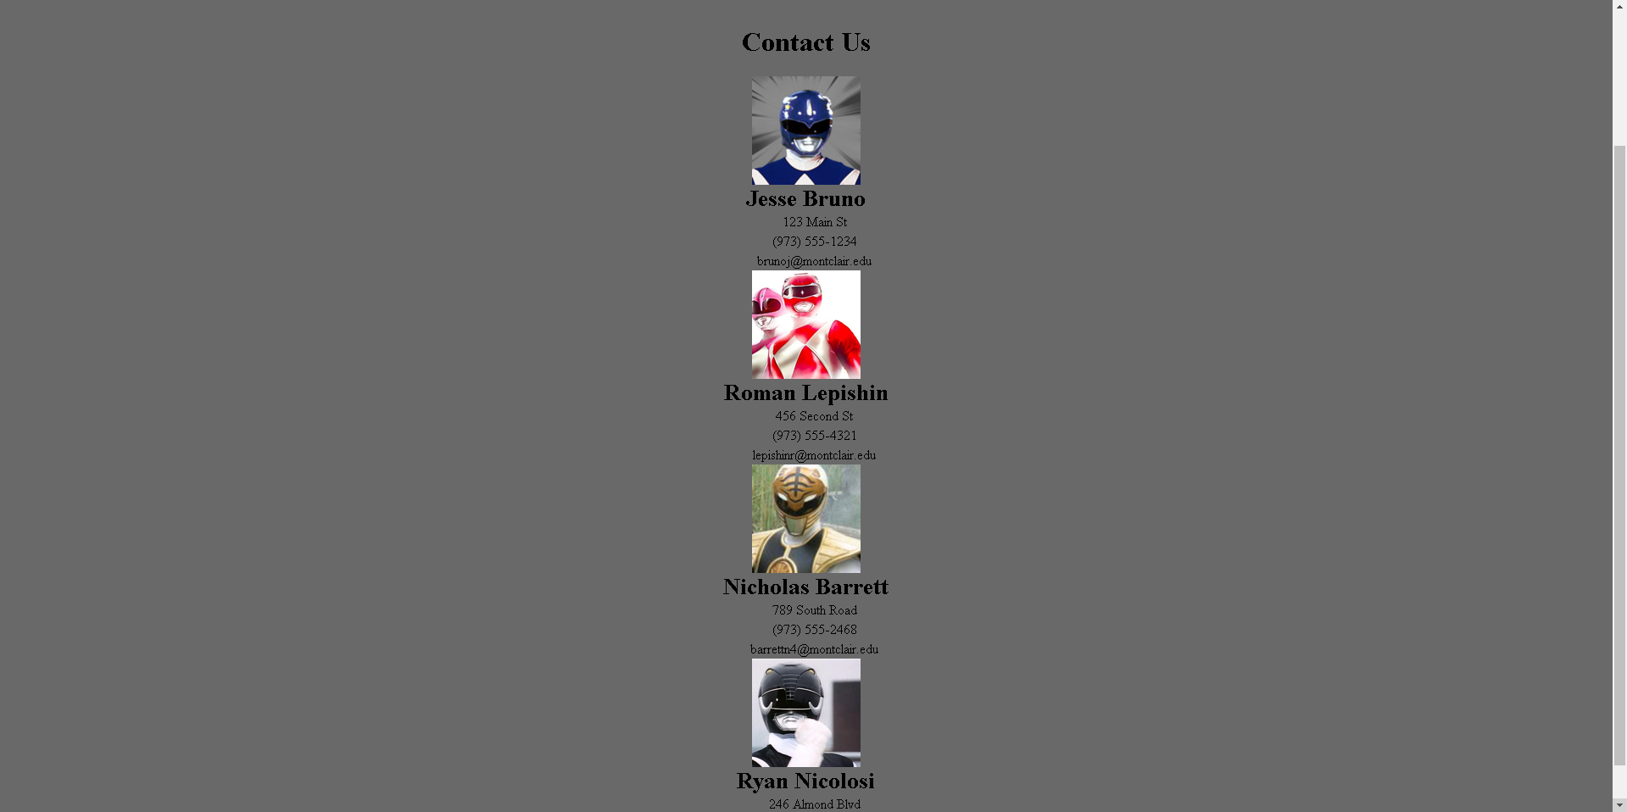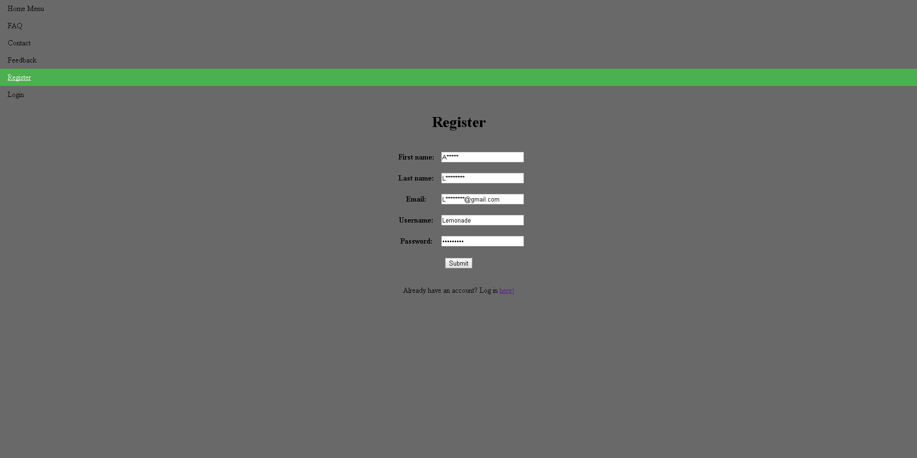

* **Subject 2:** The three tasks I gave to this participant were, Register an account, download your favorite image in the Video Game section, and to find out where the creators of the website lives. Interestingly enough the user did not go to the register page first, she went to the login page, and then clicked on the ‘click here to register an account’ button. When I asked why she didn’t just go to the register page she simply said she saw the world login first. When I asked her to download her favorite image in the Video Game section, she hovered the options at the top before clicking to go back to the home page, looking through the categories and then going to the video game section. This took her around 10 seconds to do. Then she decided the last picture was her favorite so she clicked on it to download it no problem. The final task was to find out where we lived, which she looked back to the options in the top right and then went to the contact page and found our pseudo addresses rather quickly.

**Test Results:**

**Screens Seen by Subject 3:**

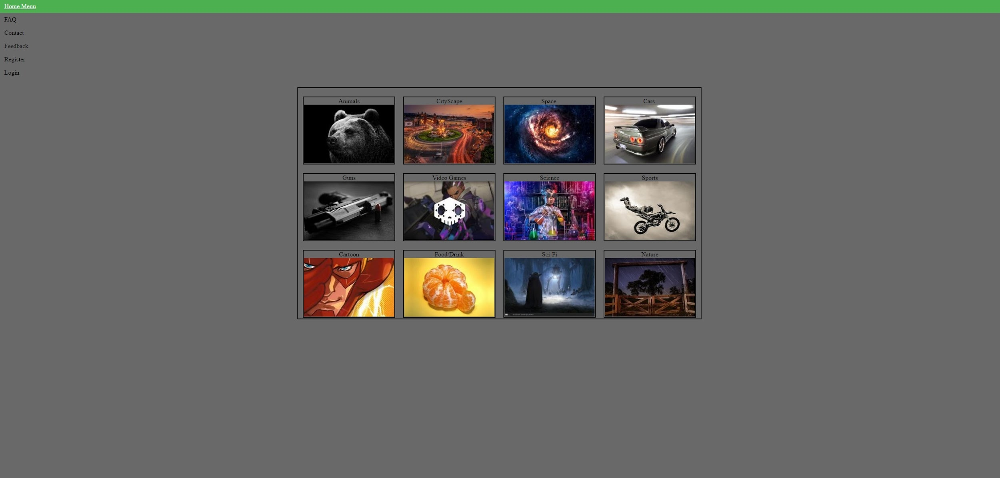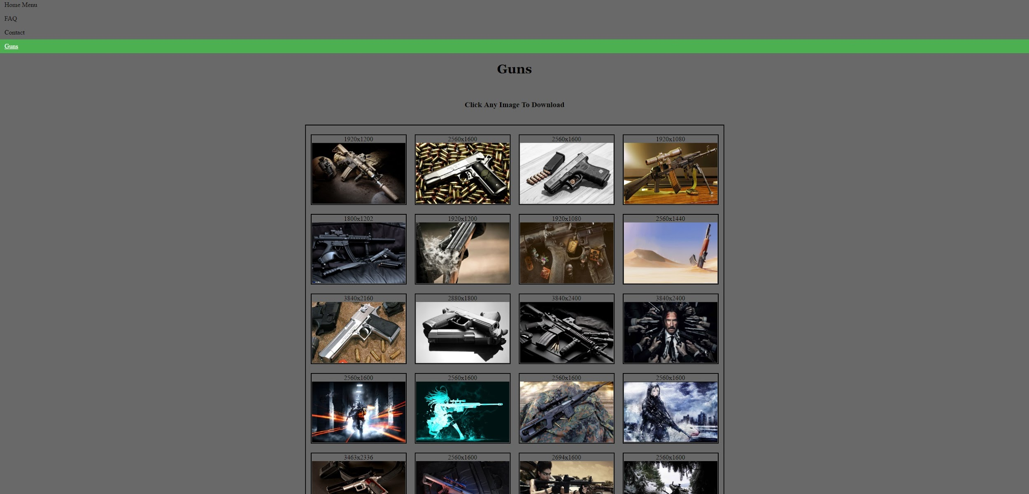

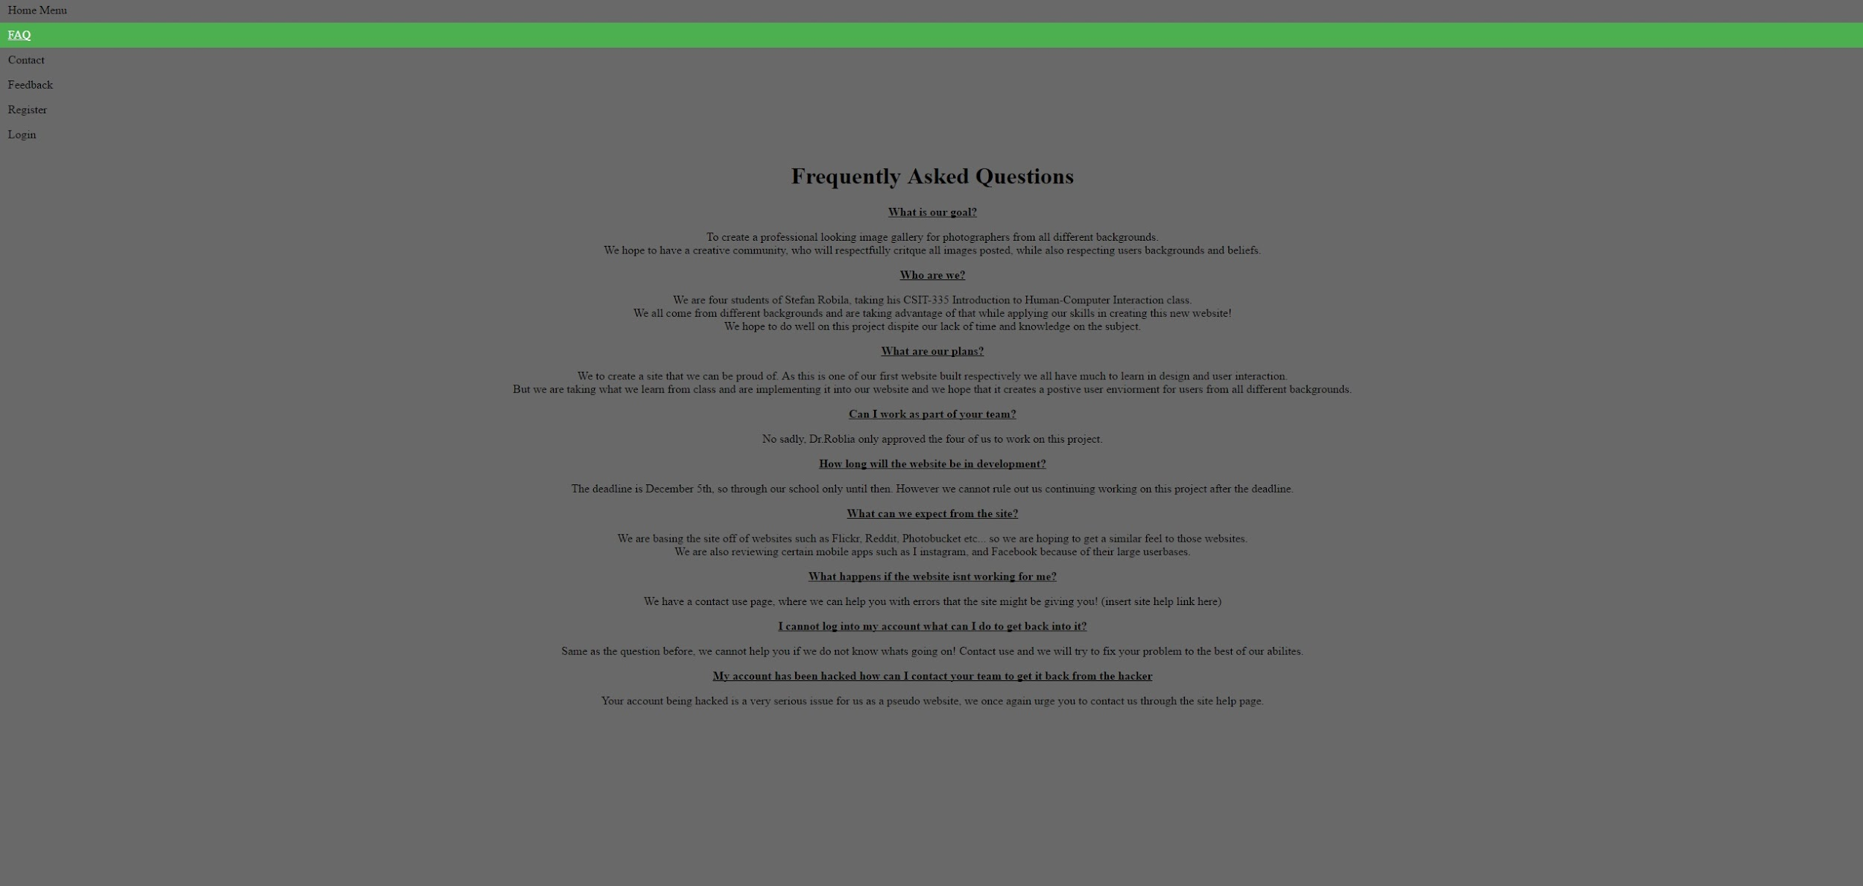

**Subject 3:** I didn’t assign my subject anything specific because they have their own site so they ought to familiar with how to navigate one. Instead I let the user go through the sites entirety to see how they felt navigating from one page to another. They commented on how moving throughout the site is very easy and seamless because of the menu options in the upper left corner. However, they did have one criticism of not being able to access the other categories while viewing one category already. They didn’t like that you had to always retreat to the home page in order to click a new category to access. They would have preferred to see a drop down menu for the categories on each page to be able to go directly to another category. Otherwise the student thought the site was well laid out and not confusing to use.

**Test Results:**

**Screens Seen by Subject 4:**

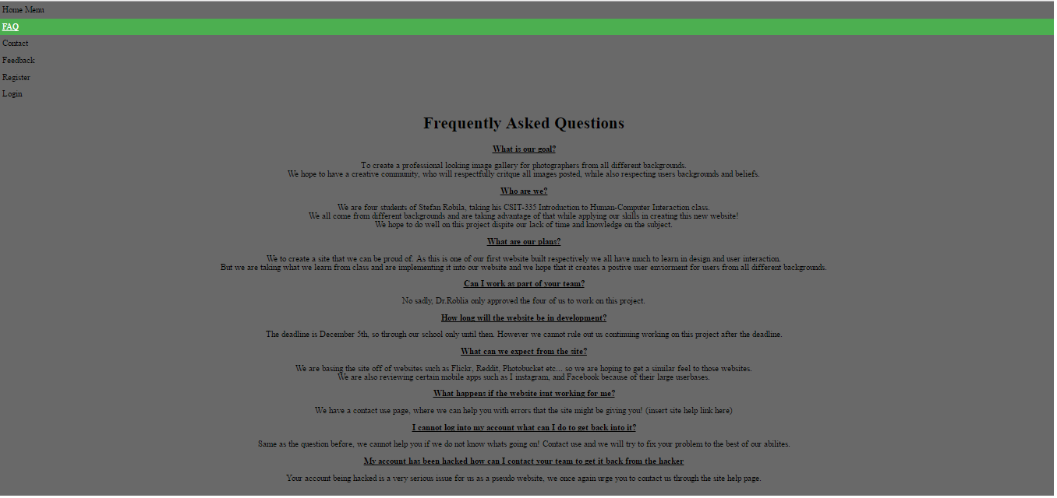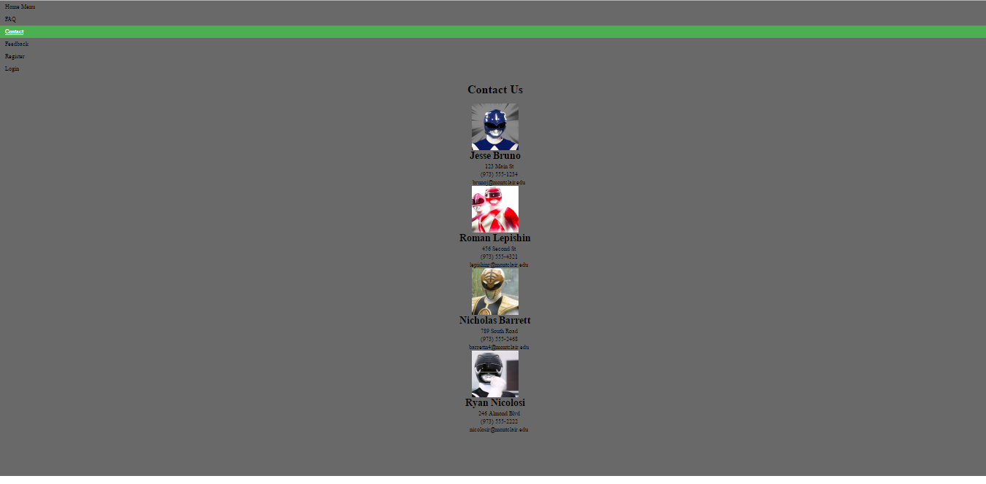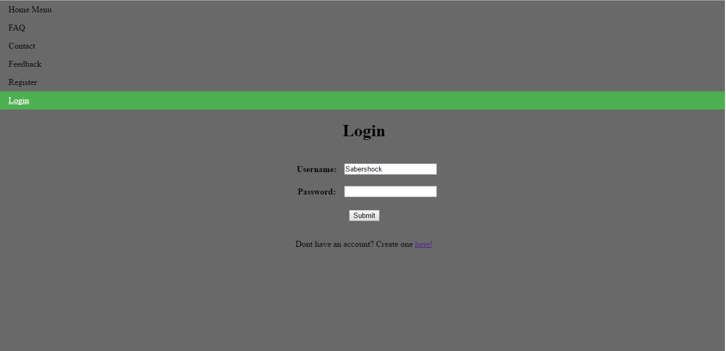

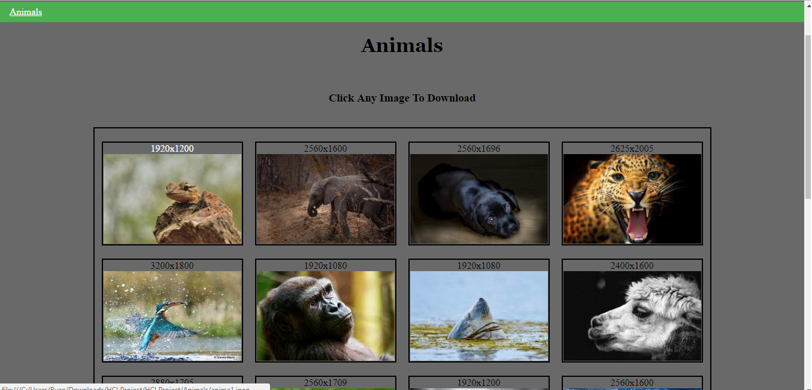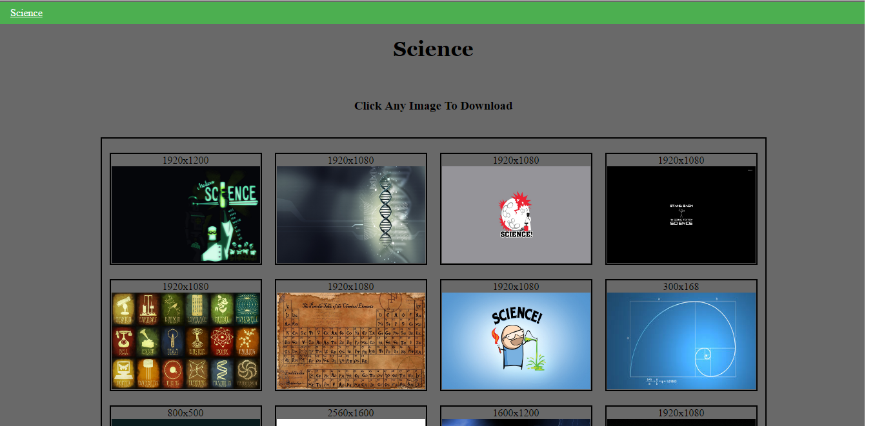

**Subject 4:** Our fourth subject was assigned 4 instructions first was to read the FAQ page, second to read the contact us page for information on us, register an account then login to the account , and then to check out the rest of the website. The subject did all that he was asked and more he commented on how the website design felt familiar and that it was easy to navigate. One criticism that the fourth subject had was the same as number three. He felt that it was rather tedious to constantly navigate back to the home page to navigate the other categories, he recommend the categories have links on the side of the page, or a drop down bar. Outside of that criticism he felt that the sight was user friendly. He felt that it was laid out effectively without any confusion on a user's perspective.

**Issues We Are Aware Of:**

Our site is nowhere near complete, taking a look at it, you can see it is very basic. If we were to continue working on the site past this class, the overall design would have to change. The plain black, while it works for our current purposes, needs an upgrade. We need to make changes to make it look more professional for a modern age of computing. Our site looks like a basic site created in the late 90’s because we used simple css and html code just to fill in proper a proper layout for the site. We would also have to recreate our layout, while it works well we would have to define a header and footer, add some contrasting colors, and definitely go for a different setup of buttons and features. Our biggest problem was the lack of server we created this website as something that is completely pseudo it is not live nor does it connect to a local host. The entire site is just html pages all interconnected through directory files. To really improve this website and make it something of next level design, we would have to add PHP and a server to add features such as logging in, signing up, posting images, and adding comments etc… We also realize that some aspects based on user inputs would have to change even further then what we have currently fixed, with more tests comes more information for us to use, we wanted to make a super simple site and we 100% accomplished that however when it comes to site layout we realize that in some cases it may not be as familiar as some users make it out to be in fact it could be considered an old style of designs. We all enjoyed creating this image gallery it was interesting to see how friends and family reacted and reported their findings to us. Overall I would say this was a fantastic learning experience and we believe that we can take the information we learned from this class and implement in many different avenues in our classes and eventual fields of work.